

**INDUSTRIAL ATTACHMENT REPORT SUBMITTED**

**BY**

**MUBWEZA SALIS**

**REG NUMBER: R175358R**

**TO**

**THE DEPARTMENT OF COMPUTER SCIENCE,**

**FACULTY OF SCIENCE**

**UNIVERSITY OF ZIMBABWE**

**IN PARTIAL FULFILLMENT OF THE REQUIREMENTS FOR THE COMPLETION OF THIRD YEAR OF HONOURS IN COMPUTER SCIENCE DEGREE PROGRAMME**

**FEBRUARY 2020**

## ABSTRACT

This report is a product of my Industrial attachment at Cassava Smartech Private Limited a subsidiary of Econet Wireless Zimbabwe (EWZ) Group. It is a partial fulfilment of the Bachelor of Science Honors Degree in Computer Science which I am pursuing at the University of Zimbabwe. The report contains information about the institution that I am attached to, a description of what I did during my attachment period in the following sections:

Information Systems –Infrastructure Department (System Support)

Network monitoring.

Configuration of VPNs and network devices such as routers, switches and wireless routers.

User support.

Pc routine maintenance.

Printer servicing and troubleshooting.

Information Systems – Service Delivery Department (MMT Support)

Change Requests creation

Mobiquity Support

System Deployments

Conducting Mobiquity user training sessions

The attachment was worthwhile as the exposure and experience has enhanced my Information Technology skills and management skills, this will go a long way in grooming me to be an IT professional. I did not just gain knowledge, but I brought solutions to challenges which were being faced by the organization, one such was motivating for the business to move from an on-premise email solution to office 365 which improved the business productivity significantly.

The document brings to light the relationship that exists between the theory and practical aspects of the program being studied.

## FOREWORD

The industrial attachment report has been written as per requested by the University of Zimbabwe. All Third-year students at the University of Zimbabwe (Bachelor of Science Honors degree in Computer Science) are required to undergo a “work related learning course HCT 380” better known as Industrial attachment. In line with that, the students are also required to compile a report which explains what the student has been doing and what they learnt during that period. This report therefore serves to furnish the activities I underwent during my attachment period at Cassava Smartech Private Limited.

Table of Contents

ABSTRACT 2

FOREWORD 3

ACKNOWLEDGEMENTS 4

Chapter 1 5

Introduction 5

Background of the company 5

Econet Mission, Vision, Values and Strategic Pillars 7

Group Structure 10

Econet Wireless Zimbabwe Organogram. 11

Econet Wireless Private limited 11

Transaction Payment Solutions (Private) Limited 11

Mutare Bottling Company (Private) Limited 12

Liquid Telecoms 12

Distributed Power Africa 12

Ugesi Energy 13

Cassava Smartech (where the student was attached) 13

Community initiatives 15

Cassava Smartech (Pvt) LTD Organogram. 17

Departments 17

Chapter 2 20

PRODUCTS AND SERVICES AT Cassava Smartech (Pvt) LTD 21

Cassava Products 21

OUR PARTNERS 32

Chapter 3 35

Major duties/activities 35

Detailed duties/activities 37

System and Technical Support 37

ServiceDesk 37

Administrative Duties 41

User training sessions 41

Challenges and problems encountered: 41

Procedures followed to solve the problems 42

Cassava Service Delivery Department (MMT Support) 42

IS Techs/ Database Management 43

IS Techs/ Dev Ops 43

System Administration 44

Chapter 4 45

Analysis of problems and solutions: 45

Problem: Unable to connect to the internet. 45

Problem: Acer Aspire one computer giving a black screen on start up 46

Problem: Computer can’t install any program 47

Problem: Computer is Slow Booting up 48

Problem: Computer Unable to download updates. 49

Problem: Computer laptop unable to obtain IP Address from the router 52

Problem: unable to communicate with serial port 53

Problem: Disabled wireless network adapter 55

Problem: unable to access Webservices on the server. 56

Problem: Operating System Misbehaving/corrupted 57

Why the option of repairing corrupted Operating System? 58

CHAPTER 5 59

Skills gained 59

Value of work experience 59

Managerial, analytical and diagnostic skills 60

CHAPTER 6 62

ATTACHMENT OBJECTIVES 62

The main objectives of the industrial attachment period are: 62

Expectations & Industrial Attachment Reality: 64

CHAPTER 7 66

Recommendations 66

Recommendations to Cassava Smartech. 66

Recommendations to UZ 67

Conclusion 68

References 69

## ACKNOWLEDGEMENTS

Praise is to the Almighty for granting me the wisdom to excel academically and climb the academic ladder to reach the stage that I am currently at. Without His grace I would not have had the opportunity to undertake this program. My enlightened gratitude goes to the Cassava Smartech Infrastructure department and Cassava Smartech MMT Support department for affording me an opportunity to work within their organization and the time they took to impart their expertise to me. I would not have done myself a good job without extending my gratitude to my senior mentor Mr. E Chaduka the Acting-CTO at Cassava Smartech, the Infrastructure manager Mr. V Mudziviri, the Service Delivery Manager Mr. D Maviza and my industrial attachment coordinator Mr. A Muchatibaya and Thanksgiving to all my lectures at University of Zimbabwe for the theory they gave me in preparation of the practical world. I would also want to extend my heartfelt gratitude to my family members for their invaluable support (financially, morally and otherwise) throughout my attachment.

# 

# Chapter 1

## Introduction

This chapter introduces Econet Wireless Zimbabwe and its background. The Company’s vision, mission and values are explored. At the end of this chapter, one should be able to match the company’s business operations with its vision, mission, values, its sense of social responsibility and what it hopes to achieve.

### Background of the company

“*A vision on its own is not enough, hard work and dedication is required to make the vision a reality*”, says Dr Strive Masiyiwa the founder of Econet Wireless International which has emerged to be the most innovative technology company of our time in Zimbabwe. Econet Wireless Zimbabwe (EWZ) is the largest mobile telecommunications service provider in the country headquartered in South Africa which is a subsidiary of Econet Global. Econet Global is a privately held and diversified telecommunications group with operations, equities and investments in almost all continents that is, Africa, Europe and the East Asia Pacific Rim, offering a range of products and services in the core areas of mobile and fixed telephone services, internet and satellite.

Econet Wireless Zimbabwe launched its network on the 10th of July 1998 and listed on 17th September 1998, by Strive Masiyiwa. It is one of the largest companies on the Zimbabwe Stock Exchange in terms of market capitalization. In 2009, the network became the first operator in Zimbabwe to launch data services under 3G technology. The company's key infrastructure at the start of 2010 included three switches. In 2009, Econet began building an extensive fibre optic network, and also commenced an accelerated rollout of other key network infrastructure. Econet mainly provides wireless telephony and has diversified into parallel markets such as 3G, 4G mobile internet access, Mobile Money Transfer services. According to a quarterly report produced by Postal and Telecommunications Regulatory Authority of Zimbabwe (POTRAZ) in 2014, Econet subscriber base soared past 9 million subscribers, a 4.1 % growth from the previous quarter. Econet recorded the largest subscriber market share of 65.3% gaining 1.3% market share from the previous quarter, writes POTRAZ in its report. The company has eventually grown to become the largest telecoms provider with an active subscriber base of over 6 million.

In order to achieve this market leadership, Econet is guided by its vision, mission, values and strategic pillars which are explained in the section below.

### Econet Mission, Vision, Values and Strategic Pillars

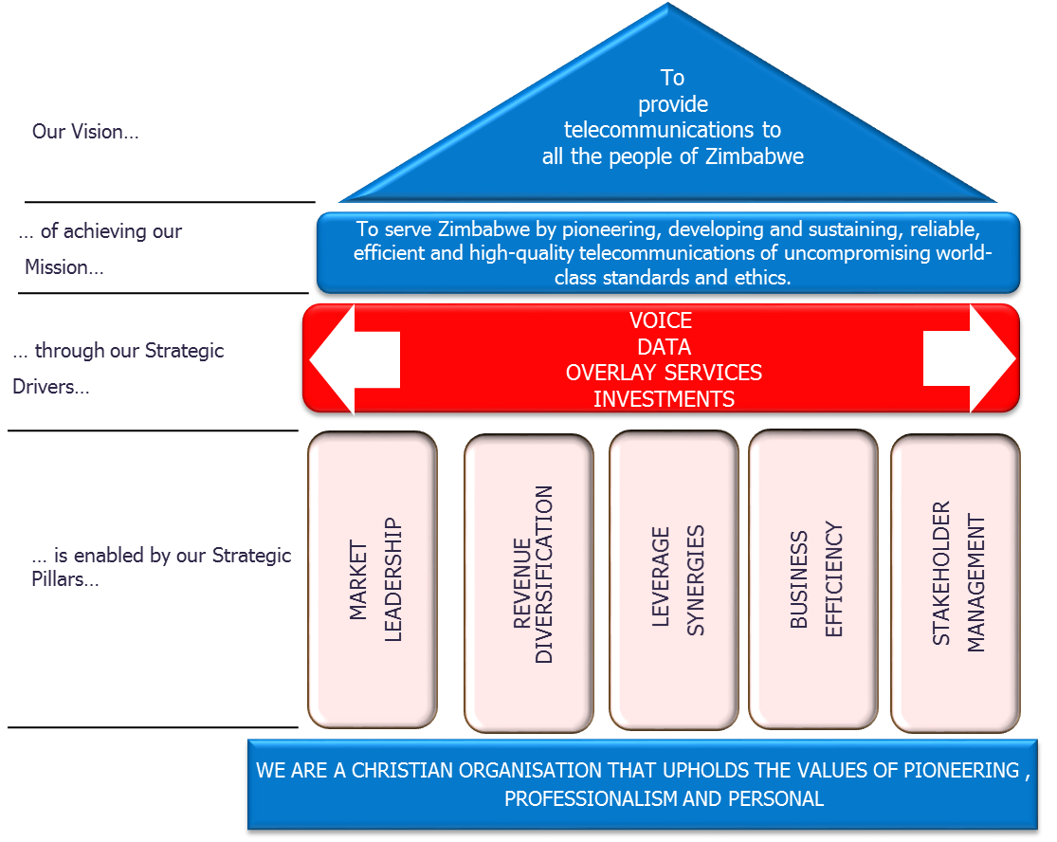

#### Vision

To provide telecommunications to all people of Zimbabwe.

#### Mission

To serve Zimbabwe by pioneering, developing and sustaining, reliable, efficient and high-quality telecommunications of uncompromising world-class standards and ethics.

#### Values

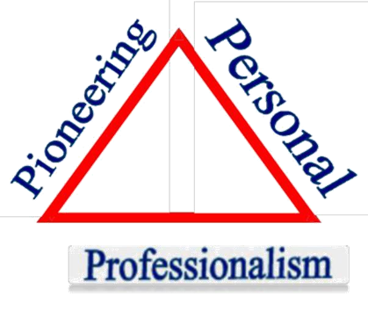

##### Pioneering

We are a company committed to finding the best way forward in the fast moving and highly competitive technological field. To remain at the top, we shall relentlessly pursue innovative solutions and constantly grow our knowledge base, with an uncompromising passion for excellence.

##### Professionalism

In everything we do, both with Econet and in the community, we always work in a customer and objective oriented manner with clearly defined goals, in terms of quality of service. In all our professional areas and at all levels, we will carry out our duties skillfully and diligently.

##### Personal

Internally we will always remember that we are a company made up of individuals. These people are the company. Each one is an intrinsically valuable member of the organization, irrespective of their gender, race or position. We will always show concern for each other in an atmosphere that is open and stimulates personal development and job satisfaction and a sense of responsibility. We believe in working in teams, in effective and confident co-operation, in environments where honest praise, constructive criticism and fair reward have their place. Who we are in the company shall reflect who we are externally. Our relationship with our customers will enthuse with warmth and a genuine desire to meet their needs. To ensure continual growth and a realization of the strategic pillars, Econet also has other subsidiaries and community initiatives.

## Group Structure

Econet Wireless Holding (EWZL) which is listed on the Zimbabwe stock exchange and has the following subsidiaries EWZ Pvt. ltd, Pentamed Investment (Private) Limited – Mutare bottling Company, Econet Services, Steward Bank and Cassava Smartech (Private) Limited.

## Econet Wireless Zimbabwe Organogram.

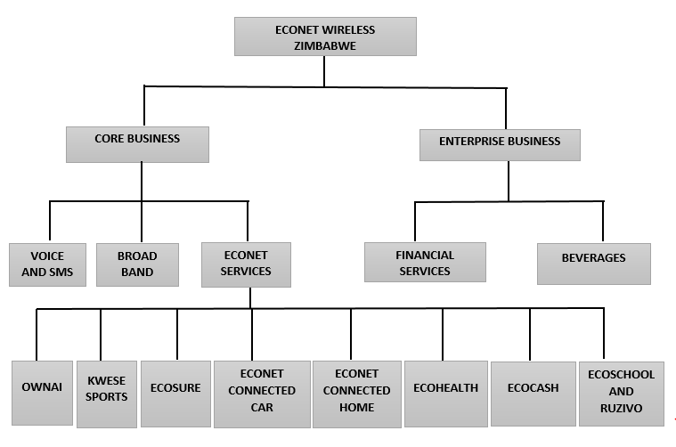

### Econet Wireless Private limited

EWZL’s largest revenue contributor being the cellular or mobile networks division. Econet Wireless Private Limited is the largest provider of Cellular Network services in the telecoms industry boosting of the largest market share based on the POTRAZ fourth Quarter Report.

### Transaction Payment Solutions (Private) Limited

Established in 1992 The company is the leading provider of financial transaction switching, point of sale and value-added services that benefits from the convergence of banking, information technology and telecommunications. The company provides local and international financial institutions and telecommunications operator’s access to cutting-edge technology to enhance customer service, in partnership with one of the world’s leading manufacturers of smart card-based point-of-sale systems.

### Mutare Bottling Company (Private) Limited

The division is a Coca-Cola franchise located in the Eastern region of Zimbabwe whose core business is the packing of beverages that are under the Coca-Cola Brand as per franchising agreement.

### Liquid Telecoms

Liquid Telecom is the leading independent data, voice and IP provider in eastern, central and southern Africa. It supplies fibre optic, satellite and international carrier services to Africa's largest mobile network operators, ISPs and businesses of all sizes. It also provides payment solutions to financial institutions and retailers, as well as award winning data storage and communication solutions to businesses across Africa and beyond. Put simply, we connect people.

### Distributed Power Africa



Powering Africa to a better future with our very own Distributed Power Africa. Provision of clean, affordable and efficient green energy that is good for us and the environment. Adding value to your real estate with a solar installation and turning your unused commercial and industrial land into a power source. Our solutions deliver on our promise to simultaneously optimize power usage and reduce cost for both commercial and residential areas.

### Ugesi Energy



Digitizing Rural Communities by Providing reliable, renewable and cost effective solar powered mini-grid solutions to rural communities. We serve rural households through our smart mini-grid solution, we can promote incubation of enterprising activities in rural communities.

### Cassava Smartech (where the student was attached)



Cassava Smartech is a diversified smartech group, with a mandate to use digital solutions to drive socio-economic development, and to improve the overall quality of life for all Africans. We are on a transformational mission and envision a future whereby our solutions are able to touch every life, bringing positive impact particularly to the millions of previously excluded Africans through provision of stable financial service with high level of integrity.

#### Vision

To provide digital solutions to all people of Africa.

#### Mission

To use innovative digital solutions and disruptive approaches to drive financial inclusion, development and improve quality of life.

#### Values:

##### Experimental

Experiment and explore, venture outside the boundaries of familiar.

##### Disruptive

Actively seek to disrupt and confront the status quo.

##### Perceptual

Envision the future. Sensitive to external realities in light of this networked global world.

### Community initiatives

#### Econet in the community

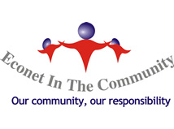Econet provides a service that contributes meaningfully to the improvement of the lives of members of the communities that we serve. Our social role is therefore constantly being reviewed in order to remain relevant to our communities.

#### National HealthCare Trust

The country's largest mobile operator Econet Wireless has been working quietly behind the scenes with various government departments, including the Ministry of Health and Child Care, to prepare Zimbabwe for any possible outbreak of Ebola.

#### Joshua Nkomo Trust (Higher Life)

The Fund is a Pan African Scholarship in honor of one of our country's founding fathers, Joshua Mqabuko Nkomo. Each year, the scholarship sponsors hundreds of the country's brightest high school and tertiary students, irrespective of social standing or race. For more information please visit

#### HIV & AIDS Policy

Econet is convinced that HIV and AIDS have the potential to waste valuable trained human resources and reduce productivity. Econet Wireless continues to provide anti-retroviral drugs for the infected employee and other members of their immediate family. Through the Live 2 Love programme, the Company continued to encourage open dialogue among staff on HIV/AIDS. By encouraging open debate on HIV and AIDS, we help remove the stigma attached to HIV and AIDS and increase access to critical information on the pandemic.

#### Christian Community Partnership Trust

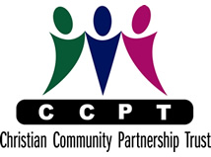This is a partnership between Econet Wireless Zimbabwe Private Limited, Kingdom Financial Holdings Private Limited and Renaissance Merchant Bank. It's key organizational objectives include providing grants, capacity building facilities and training materials to any church based, charitable and civil society organization or institution whose object is evangelism, church planting and effective discipleship in the least evangelized rural areas of Zimbabwe.

Econet Wireless as a company is explained in the chapter above. It is not just any telecommunications company. Econet Wireless Zimbabwe.

### Cassava Smartech (Pvt) LTD Organogram.

##### Executive

The Econet wireless executive is comprised of some of the most prominent names in Zimbabwean business today and is headed by the company C.E.O Mr. Douglas Mboweni. The Executive committee comprises of C.E.O and chief officers of various departments and the Finance Director who is the CEO’s right-hand man with regards important decision making.

##### Managers

Comprises of managers of various departments. They report the chief of that department

##### General employees

These are the workers who run day-to-day business of the company, from monitoring the uptimes of networks to handling customers.

### Departments

#### Finance

The major focus of the department is to provide a comprehensive fiscal policy that will make funds available in order to realize corporate goals. Finance is generally in charge of the company’s cash inflows, expenditure, investment, inventory and reporting in line with local legislation, International accounting and reporting standards and in compliance with recommendations from audit reports. The above information is also used as pointers in allocation of resources, product launch, and bolstering continuous improvement.

#### Customer Services

Customer services represents the customer facing side of Econet’s operations and is comprised of the Call Centre, Customer Care Consultants (Who operate in Econet Shops), Provisioning and SIM card. Customer care consultants are the personnel who deal with clients on a one on one basis inside Econet’s shops scattered nationwide. On the other hand, call operators from the Call Centre interact with clients over the phone. Econet has the largest fully operational call center in the country.

#### Business Continuity Management

This department manages overall business risks by ensuring that the business operates profitably through a process of planning, organizing, leading and controlling the activities of an organization in order to minimize the effects of risk. It designs systems, processes and procedures that minimize the loss of revenue to the business. It also manages the occurrence of fraudulent activities perpetrated both internally and externally and thus encourages governance and risk awareness culture within the organization.

#### Legal and Corporate Affairs

This is the regulatory arm of the organization and reports directly to the C.E.O. It provides different services related to legal and corporate issues. It makes sure that all policies implemented, managerial decisions made, agreements entered by the company comply with corporate governance, company law and regulatory body requirements such as those set by POTRAZ. It also makes sure that the company is always safe from litigation in all of its operations, from customers, competitors, environmental bodies, suppliers, shareholders and investors, employees and all other stakeholders.

#### Marketing and Sales

Marketing is mainly responsible for developing promotional material and increasing customer awareness of the company in its target markets. It also designs packages to counter actions of its direct competitors mainly Telecel and Netone, and so maintain and/or increase the company’s market share. They also use the tools of brand management, advertising and promotion to build customer loyalty and for communicating the presence of the organization into the market. It is also responsible for the distribution of the company’s products and the processing of customers’ orders.

#### Networks

This is the hardware portion of Econet’s operation, responsible for all the Base Stations and networking transmitting equipment as well as telephone exchange and mobile data and WiMAX technology. The department is mostly staffed with telecommunications engineers and is comprised of two broad divisions which are Network Services and Projects Division. Network Services is the engineering department and is responsible for the designing, planning, implementing, maintenance and operating the hardware and software entities that constitute the ECONET GSM cellular network. On the other hand, the Projects division is responsible for site acquisitions, civil and structural work as well as installations of equipment which it later hands over to the Networks division for its operations and maintenance after the new infrastructure has been fully installed.

#### Information Systems

This is the department with which the author was attached for the entirety of the attachment period. Information Systems is responsible for any and all issues pertaining Information Technology within the company. It is further divided into five functional areas, and each area is headed by an HOD, all of whom report directly to the CEO. It is staffed with a wide variety of IT professionals, including developers, database administrators, networking specialists, engineers, software testers, security specialists and so on.

# Chapter 2

## PRODUCTS AND SERVICES AT Cassava Smartech (Pvt) LTD

This chapter will focus on the products and services that Cassava Smartech (Pvt) LTD currently provides to their Clients, and the products that Cassava Smartech (Pvt) LTD currently has on the market.

## Cassava Products

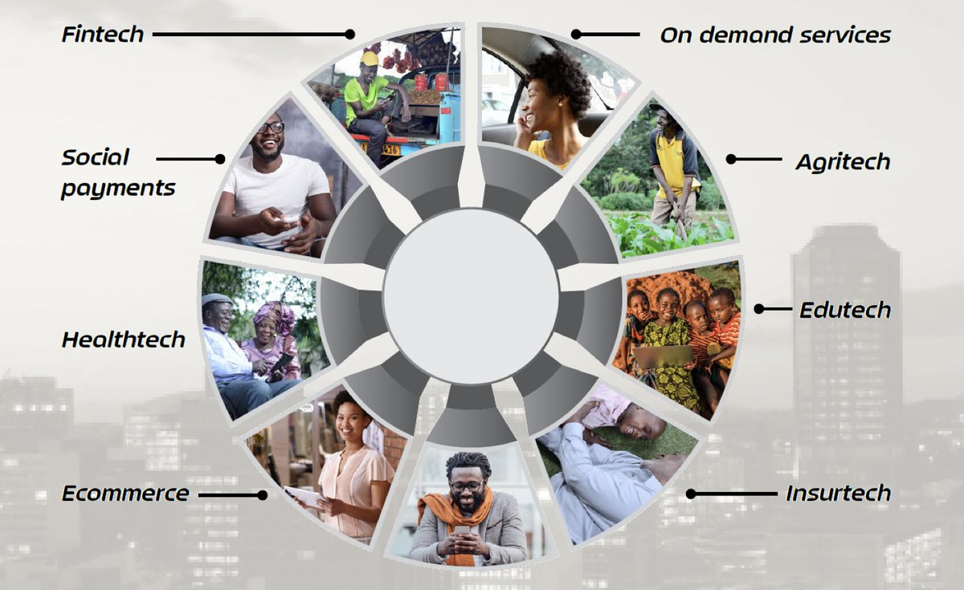

#### Fintech

Our Fintech section is comprised of the following:

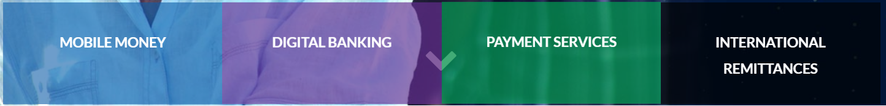

##### Mobile Money

Our integrated platform offers multi-mobile financial services programmes, which depending on the target market, can be tailored to suit banked, unbanked and under-banked customer segments. We offer a rich pipeline of innovative use cases, including micro-loans, micro-savings (for individuals or groups), mobile business wallets, international remittances, and merchant payment solutions. Our flagship mobile money service, EcoCash, is a recipient of two GSMA GLOMO Awards for Best Mobile Money in the World (2017), and Best Mobile Innovation for Women in Emerging Markets (2018). It has many more awards to its name, and widely considered one of the best mobile money services in the world

##### Digital Banking

We follow a transactional banking model, with the following as key offerings: Micro-loans, Savings, Agent Banking (designed to reach the previously excluded), Device Financing and Diaspora Banking. The Digital Bank’s flagship platform is branded “Square”. The Square Mobile App is an integrated mobile banking solution that gives customers the ability to transact wherever they are, on services such as bill payments, funds transfer, banking services, nano loans, airtime and so forth.

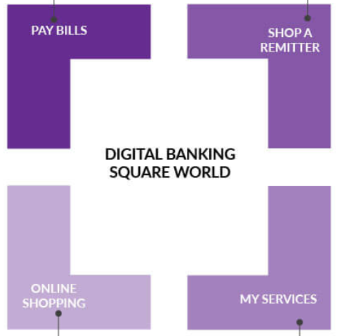

##### Payment Services

Cassava offers payment solutions and services targeting financial and retail sector players, and merchants operating in Africa. Payment collection and processing is facilitated through the pan-African Cassava Payment Gateway, with the solution being able to support different channels and markets across the continent. Typical customers for such services include Pay TV operators, retailers, billers and e-commerce players.

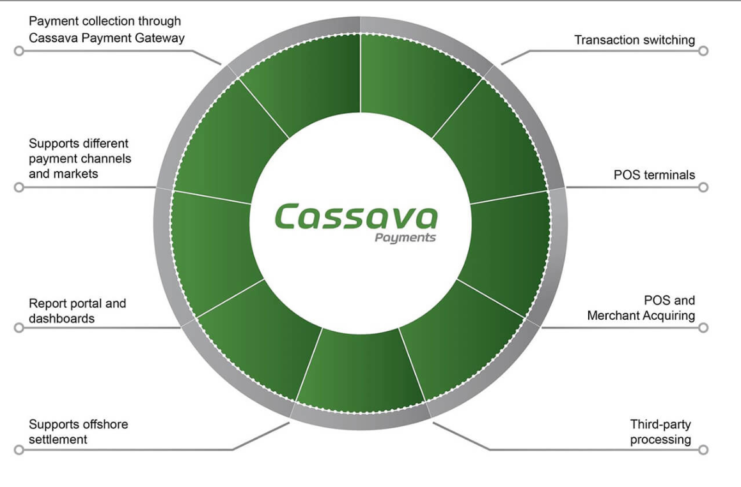

##### International Remittances

Tailored solutions for Africans in the diaspora to send money back home. Cassava has both first-mile and last-mile remittances play, meaning we have capabilities in both send and receive markets. In the UK and South Africa, both major source markets for remittances to Africa, we operate full-fledged remittance businesses helping channel millions of dollars in international transfers to Africa. Further, we work with several major international money transfer partners ensuring that we can offer remittances to Africa from all major source markets including US, Canada, Europe and Gulf countries.

#### Social Payments

 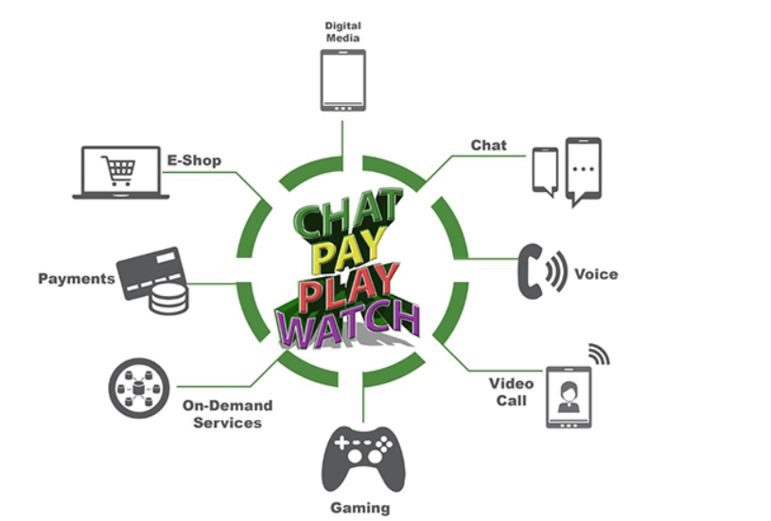

The emergence of social networks and messaging apps in recent years has provided an opportunity to grow payments, both peer to peer on the same network, and payment for a plethora of goods and services. In Africa, Cassava is leading the way in this area, and we believe “social payments” is the next wave of mobile money growth. We have developed an integrated social payments platform that leverages our pan-African payments infrastructure and combines social chat and mobile money payments in a single app. Through our super-app (Sasai), customers can chat (text, voice and video) with their friends and relatives, send money, and pay for virtually anything, on the fly. We believe this holds enormous potential to drive digital payments in Africa, given the almost ubiquitous presence of mobile money, and rapid adoption of social media.

#### Healthtech (Maisha Medik)

Maisha Medik is a one stop shop for all your medical needs through granting you access to an extensive network of doctors, dentists, pharmacists, laboratories, clinics, hospitals and other health service providers in Zimbabwe. As a patient, Maisha offers you secure access and control over your personal, medical history and records. Access your clinical records including

prescriptions, lab results and scans from anywhere, anytime!

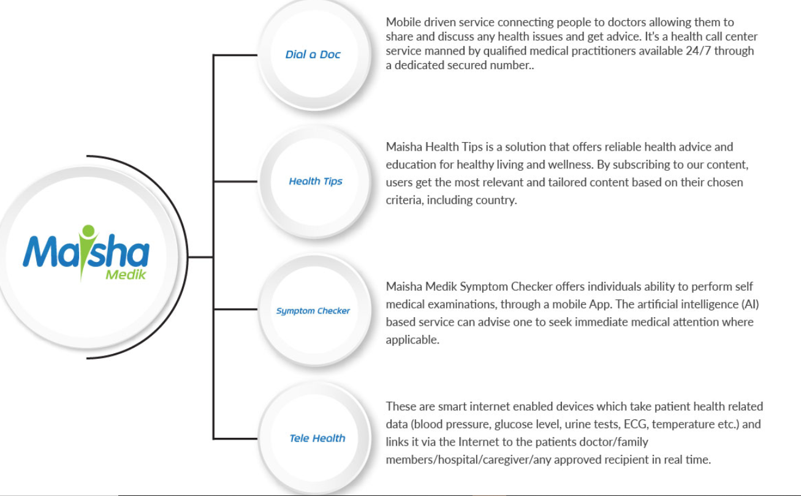

#### Ecommerce

Our Ecommerce section covers the following areas:



##### Online Classifieds

Ownai Classifieds is an online marketplace for buyers and sellers, with a strong focus on promoting small businesses and growth of the informal sector. Our value proposition is supported through the provision of a platform that allows buyers and sellers to transact in a safe, secure and convenient manner.

##### E-Store

Ownai developed the Kwese TV eStore platform, Africa’s newest and fastest-growing pay TV service. Our model involves delivering white-labelled eStore platforms for MNO’s, retailers and other parties. The Kwese eStore platform allows customers to buy satellite dishes, set-top boxes/ decoders, accessories and even pay subscriptions from the comfort of their homes.

##### Online Market Place (Ownai)

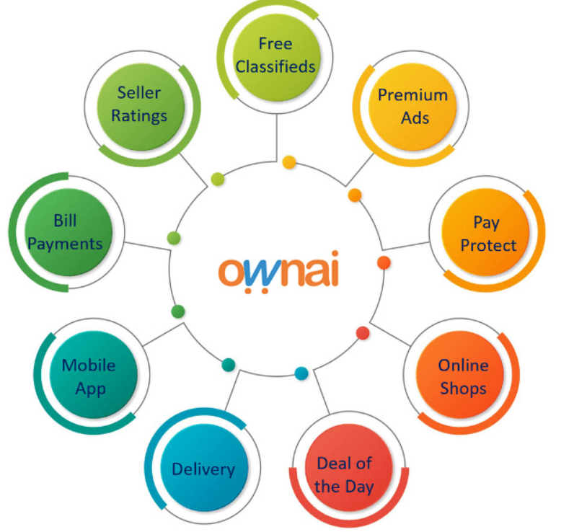

Ownai is a subsidiary of Cassava Smartech a diversified smartech group, with a mandate to use digital solutions to drive socio-economic development, and to improve the overall quality of life for all Africans. We are on a transformational mission, and envision a future whereby our solutions are able to touch every life, bringing positive impact particularly to the millions of previously excluded Africans through provision of stable financial service with high level of integrity.

#### On Demand Services

##### Vaya



Vaya Africa (Vaya means “Let’s Go” in Ndebele) is an on-demand data driven technology and platform company focusing on efficient, affordable and reliable transportation of goods and movement of people across Africa working together with strategic partners. Technology inclusion and digital transformation of the logistics and mobility industry in Africa is a great opportunity which we aim to embrace as we create sustainable value for our customers and partners. Vaya Africa will offer Mobility as a Service and Logistics as a Service across the African continent as we drive the economic and social growth of our continent and unlock and support the growth of new economies supported by an efficient mobility and logistics industry.

##### Technites

Cassava Technites are trained and certified technicians that are deployed to customer sites on an on-demand basis. The Technites business model involves deploying independent contractors to customer sites. Contractors will be trained and certified (as “Technites”). The business will offer flexible resourcing through an on demand technological platform.

#### Agritech

Our end to end mAgric solution for smallholder farmers offers a wide range of tailored services under financial services, information, trading and logistics. Our platform aggregates key value chain players and stakeholders, creating a powerful agricultural ecosystem designed to transform the sector and improve the livelihoods of farmers.

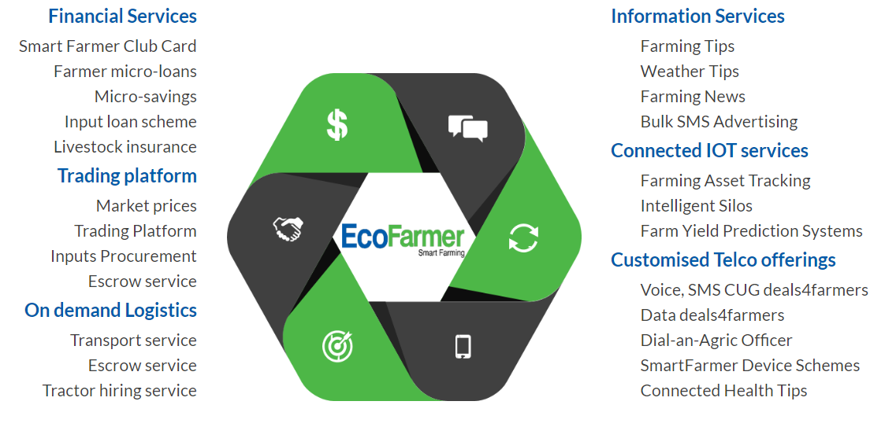

#### Edutech

##### Online Learning

###### Ruzivo Smart Learning



Ruzivo Digital Learning offers an online interactive digital learning platform targeted at primary and secondary students. All our content is aligned to the national school curricula, and offered in conjunction with Ministries of Education in the different countries.

###### Simba Education



Simba Education platform is an online web platform offering early childhood education, targeting the pre-school segment. It is accessible to teachers, parents and learners, with features that include step-by-step instructions for teachers, activities for parents, student report tools and high levels of customization.

##### Online Books



Akello Books is an ebook store platform that provides academic and non-academic affordable and reliable access to world-class content. The platform goes beyond simply making books available at a cheaper price but is part of a larger strategy to help Africans gain access to current educational materials and specialised content from across the globe.

##### Skills Development



Offered through Muzinda Hub, a tech hub committed to building and supporting an engaged and talented community of tech enthusiasts and IT professionals. Their highly sought-after Digital Skills Training Program consists of: specialised e-learning coding modules, Google certification, business & entrepreneurship skills training; and practical group project development experience.

Our partners are:

1. Shawacademy
2. Treehouse
3. Snapplify.com
4. extramarks

#### Insurtech

Our Insurtech covers the following areas:



##### Funeral (EcoSure)

Mobile micro insurance product, which pays a funeral benefit upon death of the insured life. For millions in Africa, the pain from the loss of a loved one is further aggravated by the hassle of finding resources to ensure their decent funeral. Being a micro-insurance product, our funeral cover is low-cost, with premiums starting as low as 50 cents per month and designed to attract the previously excluded. Our funeral product has received awards in some of our markets, with recognition in the area of innovation and adoption.

##### Auto (Moovah)

Auto insurance product, providing cover against injury or damage in a motor vehicle accident. It is one of the first mobile phone-based auto insurance products in Africa, with a value proposition based on flexible payment terms, convenience, ease of use (digitized, and available via Mobile App), and 24-hour claims pay out.

##### Education (Tasknites)

Life term insurance product whereby an education benefit payout is made for the duration of a child’s primary or secondary school education (or both) in the event of the death of a parent or legal guardian. Designed for the pre-tertiary education phase, the educational benefit is paid in the form of school fees directly to the beneficiary school until the child completes primary school, high school or drops out or until they pass on whichever comes first.

##### Health (Karigo)

Mobile micro insurance health cover against the cost of diseases and accidents causing injury. It is designed to lighten the financial burden with a guaranteed cash back benefit for each day spent in hospital in the event of hospitalization for more than 72hrs.

## OUR PARTNERS

Chartered Systems Integration works with a number of local, international partners and vendors such as:

|  |  |
| --- | --- |
| [Microsoft](http://www.microsoft.com/) | Microsoft was founded in 1975 and is headquartered in Redmond, Washington. Chartered Systems Integration is a Microsoft Certified Partner. This allows the company:  To have solutions independently validated by a third party.  To exploit the experience of leading technical and industry experts worldwide. Premier access to all Microsoft technologies, including the newest and most innovative. Exclusive developer and technical support from Microsoft. |

|  |  |
| --- | --- |
| [IBM](http://www.ibm.com/) | In addition to being the world’s largest IT and consulting services company, IBM is a global business and technology leader, innovating in research and development to shape the future of society at large. IBM’s prized research, development and technical talent around the world partner with governments, corporations, thinkers and doers on ground breaking real world problems to help make the world work better and build a smarter planet.  Chartered Systems Integration is an IBM Independent Software Vendor (ISV). |

|  |  |
| --- | --- |
| [Cisco](http://www.cisco.com/) | CISCO Systems, Inc. is the worldwide leader in networking for the Internet. Today, networks are an essential part of business, education, government, and home communications. CISCO hardware, software and service offerings are used to create the Internet solutions that make these networks possible, giving individuals, companies, and countries easy access to information anywhere, at any time. A tradition of IP innovation continues with the development of industry-leading products in the core technologies of routing and switching, along with Advanced Technologies in areas such as home networking, IP telephony, optical networking, security, storage area networking and wireless technology. In addition to its products, CSI provides a broad range of service offerings, including technical support and advanced services on all CISCO products. |

|  |  |
| --- | --- |
| [Symantec](http://www.symantec.com/) | Symantec is a global leader in providing security, storage and systems management solutions. By partnering with Symantec, CSI helps consumers and businesses, right up to the largest global organizations to secure and manage their information against more risks at more points, more completely and efficiently than any other company. Our focus is to eliminate risks to information, technology and processes independent of the device, platform, interaction or location. |

|  |  |
| --- | --- |
| [Abiquo](http://www.abiquo.com/) | Abiquo is a leading provider of Cloud management solutions. Abiquo envisions a future where private and public Clouds are fully interoperable and vendor neutral. The company embraces an open-source model where both community users and commercial organizations can fully benefit from the Cloud revolution. CSI has recently partnered up with Abiquo to bring Cloud computing to Zimbabwe and the region. |

# Chapter 3

## Major duties/activities

From the very first few months I worked closely with my supervisor. It was an interesting introduction to working in such a big organization, it was orientation to get introduced to the current and best approaches to IT.

My first half of attachment was in connected lifestyle department which consisted of 2 products, connected home and connected car.

I had to offer technical support in the control room and the duties are explained further below.

Being on attachment I was required to know all aspects of operations that is from technical to administrative roles. In some cases I would be required to organize and facilitate technical support at major expos or events, and because of this I had to develop managerial skills of planning and mobilizing before I could apply my technical skills at the event

I was afforded a great opportunity to join IS operations and Billing during which is a section of Information Systems department, during the second half of my attachment.

Due to the limited time I had in this section, I had an opportunity to work in IS help desk, network and infrastructure as well as data centre

The major duties that I carried out in connected lifestyle under the supervision of my super visor are below.

* Tracker unit preparation.
* Troubleshooting offline trackers.
* Confirmation of repairs, removals and installations of trackers using toll free line 149.
* Creating login details for new users.
* Facilitating user training sessions.

The major duties that I carried out in IS operations and billing under the supervision of my super visor are below.

* Network monitoring and troubleshooting
* Creating site to site vpns and remote access vpns
* Voip phones troubleshooting
* Computer maintenance
* User support
* Email configuration

## Detailed duties/activities

Below are the duties I performed while I was attached in connected lifestyle and IS operations and Billing:

## System and Technical Support

### ServiceDesk

#### Overview

ServiceDesk or Helpdesk is the first pot of call in IS. All IT related issues are first directed to Helpdesk. Only when the department uses a system called Manage Engine to allocate jobs to respective departments.

The help desk oversees internal hardware and software fixes for either work stations, or other pertinent hardware. They are also responsible for purchasing of new hardware, be it routers, lap-tops, phones, etc. (With the exception of hardware for the GSM network which is handled by the Networks department).

#### Responsibilities

Routine maintenance and troubleshooting were the major role in this department I performed functionality test for about 100 IT equipment, including laptops, printers, desktop pcs, MacBook’s. I returned working equipment to the office for re-use. I circulated my own user access form for sign-offs so that my account was created on various systems so that I gained access I logged into my ManageEngine account first thing before start of business to see jobs that allocated to me. I had to make sure that by end of day all job tickets allocated to me had been closed. Because I was part of ServiceDesk, I was given administrative rights to ManageEngine console so I could allocate jobs to other IS employees.

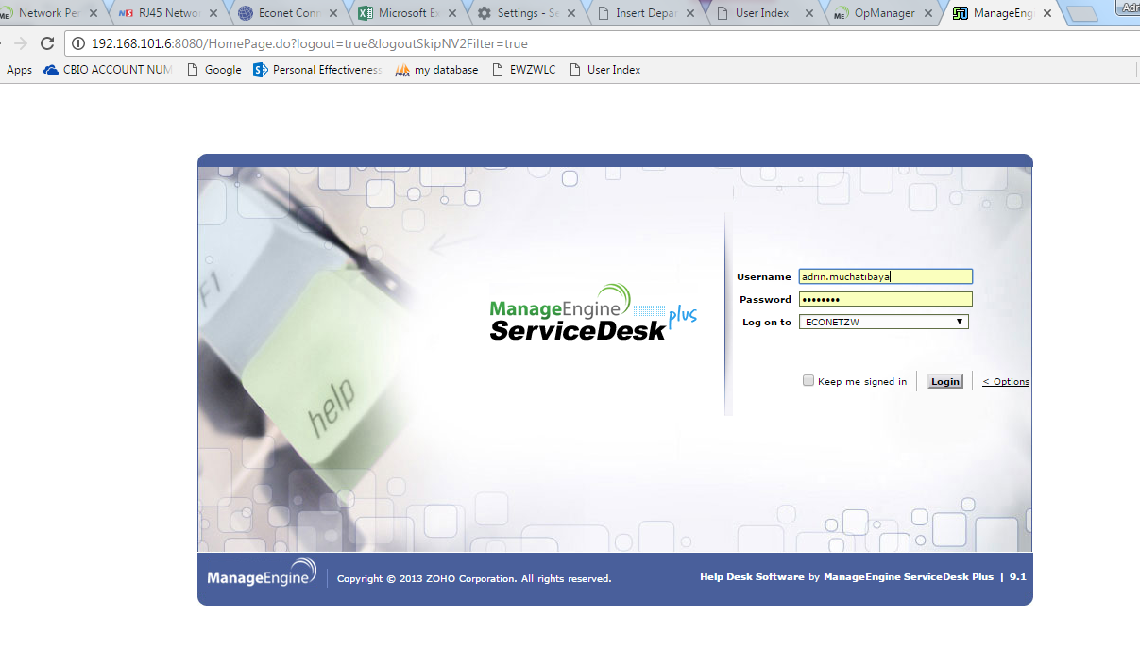

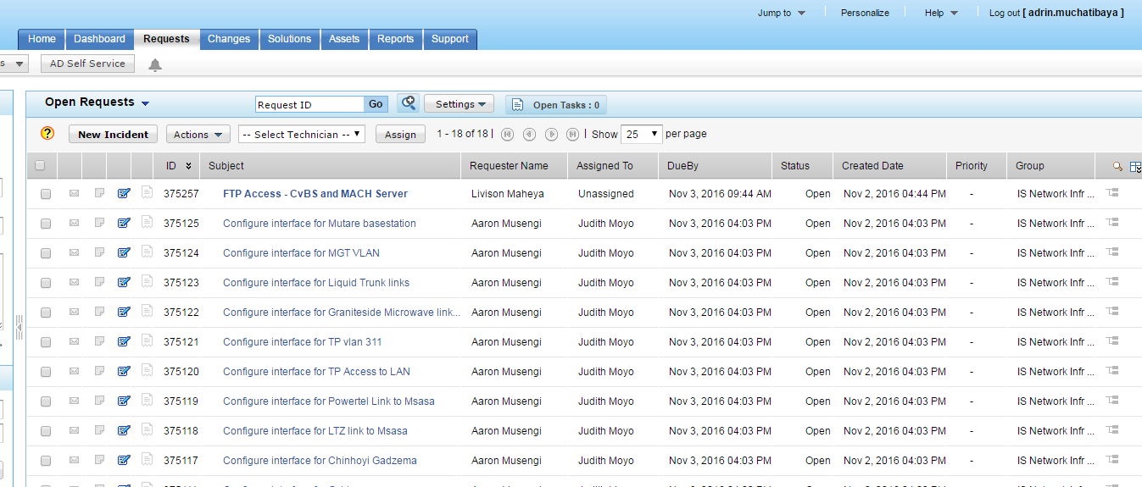*Fig – ManageEngine ServiceDesk Plus log-in page*

*Fig – ManageEngine ServiceDesk Plus dashboard*

I allocated jobs to respective departments according to the type of job. I unlocked accounts using Active Directory. I reset passwords of users while using AD. I answered calls from HelpDesk line. I attended to users different queries.

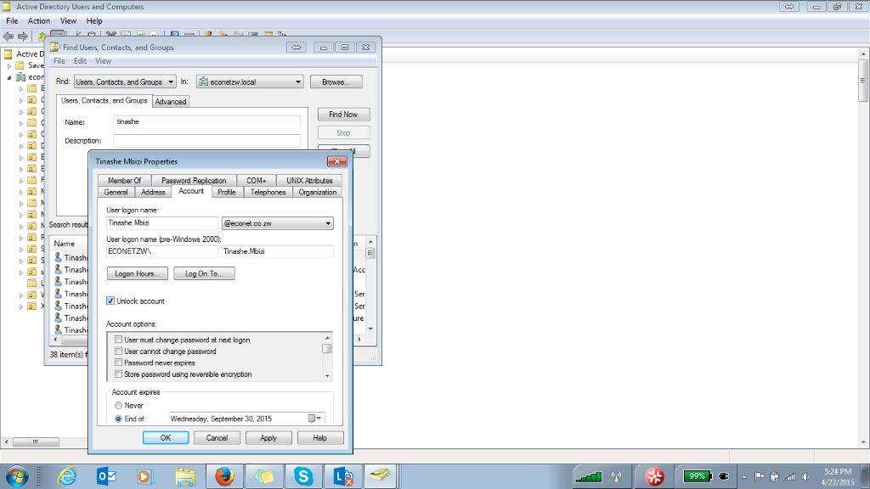

*Fig – Active Directory Users and Computer application*

I downloaded Xerox printer drivers from the network folder and installed on all newly configured HP ProOne 400 G2 All-in-one PC’s before they were distributed. I opened devices and printers on Windows, selected add printer then scanned for printer IP address. I performed regular office duties. It is customary in Econet that students on attachment do the running around to know the feel of the place. I sometimes volunteered to do the duties. The environment made me comfortable. I helped users with personal issues at times.

#### Network Support

The writer was responsible for maintenance of the organization network. He had access to all the local network servers. Whenever network was down, he had to do some troubleshooting and find out where the problem originated from. At times he interacted with people from AFROX if the problem on the organization intranet originated from the international servers in South Africa. The author was also responsible for managing the wireless network as he was expected to configure the routers and administer the subscription payment process from requisitioning to receipting.

#### Distributing IT Equipment to employees

The author was responsible for keeping computers, computer components, toner cartridges and any other IT equipment. When certain printer toner cartridges reported to Be empty, the user had to take the empty cartridge to the writer and request a new one. Users filled a stationery requisition which the author kept for record keeping. Similarly, for any component that malfunctioned the user Brought the component to the author for replacement.

#### Computer Repairing

The writer had the priviƖege to attend to empƖoyees’ fauƖty machines.

### Administrative Duties

These were duties I had to do out of the technical issues I was assigned, these also included planning for expo’s as well as major exhibiting events hosted by Cassava Smartech (Pvt) Ltd.

### User training sessions

### Challenges and problems encountered:

* When attending support calls, users may have attempted to fix problems themselves and fail to be fully honest about what settings they have tempered with upon getting assistance.
* Users failing to access the system as a result of using the wrong url
* Users still using browsers like explorer or opera which may not be compatible with the system
* Tracker unit failing to report(online status) as a result of pointing to the wrong server

### **Procedures followed to solve the problems**

* When attending support calls it is important to have check list and to be very thorough in diagnosing the system for the error, it is rare that a user will own up to what error he caused whilst tampering with the system, it is therefore wise to have a check list of all the possible causes and likely fixes to that issue..
* When a user is connected to the internet, the port number maybe blocked therefore you need to check if port 8080 is open to allow access to the system.
* When the tracker unit has gone offline, follow the correct troubleshooting steps, some units may not respond to sms commands immediately
* When training users to use the system it is important to train them thoroughly and be patient with them, do not leave them until you are satisfied that they now know how to use the system not when they say that they now understand. Having them thoroughly trained will defiantly reduce the number of support call issues that you would experience. It’s important to check if the user is using chrome or firefox

## Cassava Service Delivery Department (MMT Support)

Econet’s Information Systems (IS) department is responsible for all issues relating to

Information Technology, Information Security, Business Intelligence Reporting, Billing, Systems Support and Local Area Networking. It is a big part of the company and works closely with the Commercial Department, Networks Department, Project Management Office, and Finance. Information Systems is divided into four departments. These are Billing, Operations, Security and Applications. It is one of Econet Wireless Zimbabwe largest and most important department due to its contributions to the business. Through supporting users remotely, to configuring PC’s and laptops used around the organizations.

Due to my limited time, I was not able to work in all divisions but below is a report of the departments I worked in within IS

### IS Techs/ Database Management

#### Overview

The author gained knowledge on writing SQƖ scripts to retrieve certain data from databases. His immediate supervisor, Mr. Mike Mbewe guided him with instructions on how to transact certain queries. The databases are a very sensitive part of the Ɩinde group of companies, as such, the writer gained shallow knowledge in the area as he was restricted access. At times Mr. Mbewe, knowing the company did not offer the author a lot of challenging duties in his preferred area of expertise, he gave him tutorials on handing the databases then he would give him a portion of queries to run. This Benefited the writer as he gained experience in administering “real-life databases”.

#### Database Monitoring and troubleshooting

### IS Techs/ Dev Ops

#### Overview

#### Innovative Implementations

### System Administration

System administration handles the company’s domain and manages user’s access to various resources of the organization. It also employs several Database Administrators who manage access to the company’s databases.

# Chapter 4

## Analysis of problems and solutions:

### Problem: Unable to connect to the internet.

**Solution** : Put Internet settings on Web Browser

Procedure:

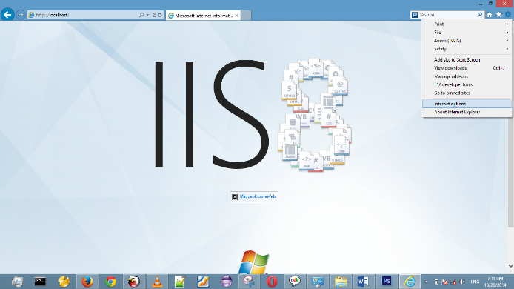**Step 1**: open internet Explorer and click the settings icon in the top right corner

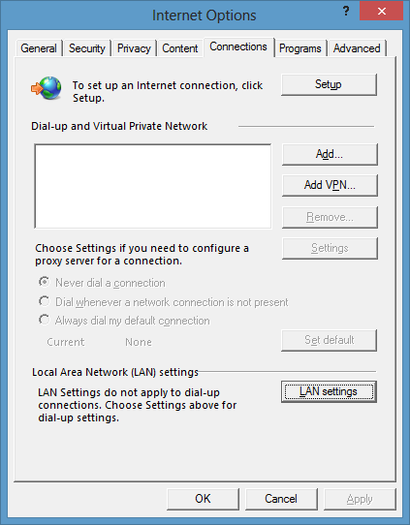

**Step 2**: select internet options and this dialog box appears and select “connections” tab

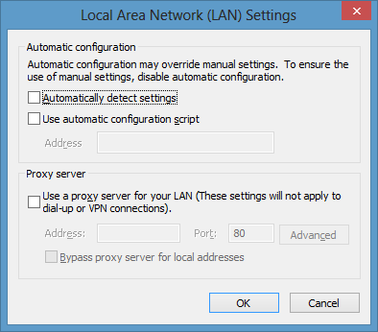

**Step 3**: click “LAN Settings” and this dialog box will appear select option “automatically detect settings” and click okay button. Click okay again to close the previous dialog box and you may now access the internet.

### Problem: Acer Aspire one computer giving a black screen on start up

**Solution**: Preforming a hard bios resetThe aspire one manufacturer has admitted that the Aspire one has a faulty bios and has provided a work around for it.

**Step 1**: Check your aspire one bios version and download the correct bios boot files from this website http://www.bios-mods.com/downloads **10/07/14 12:30 PM**

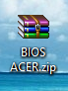**Step 2**: download the .zip file and extract its contests. To a folder. You will need to use winrar.exe tool to extarct the contents.

**Step 3:** the extracted contents should look like the following.

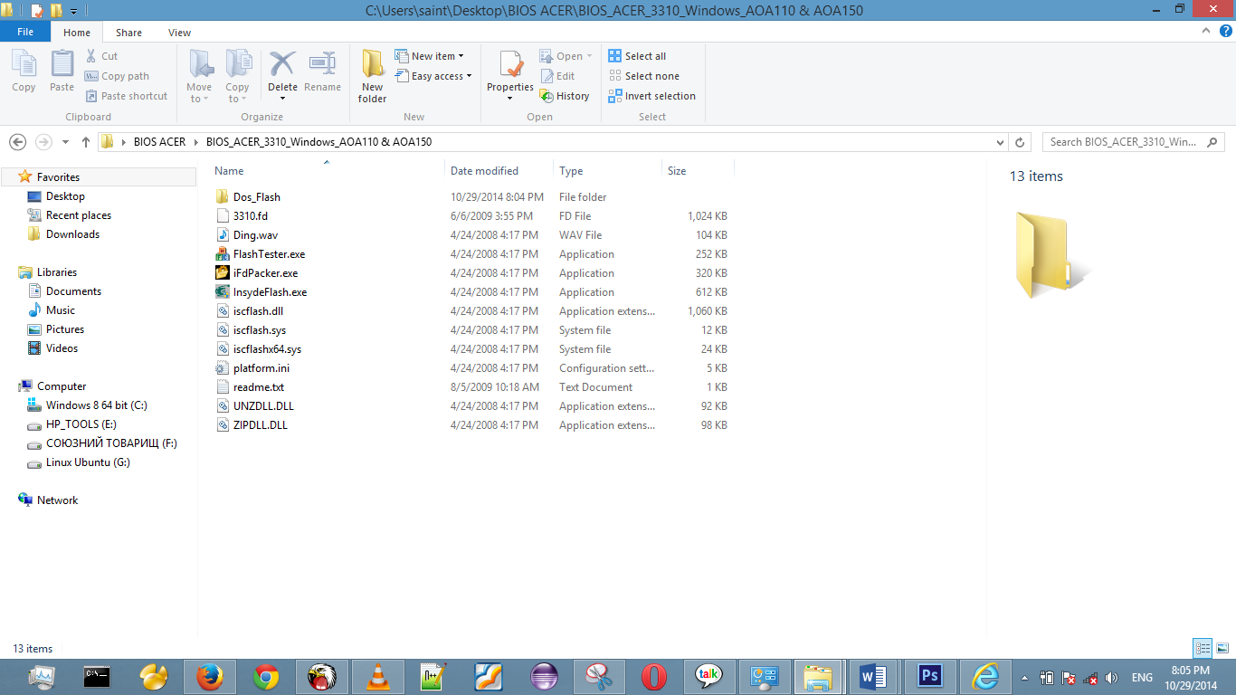

You should be having only 13 items.

**Step 4:** Copy the files onto a blank cd or flash drive and plug in the flash drive into the acer computer to boot up the acer computer using the files.

Press the on button together with the “fn” key and the on button will start to flicker press the on button one more time and and your acer computer will immediately start to boot up from the flash drive this is called a hard bios reset and resets the bios errors on the computer.

### Problem: Computer can’t install any program

Some times when trying to install a program or an application the windows installer service can go offline and you will not be able to install any programs.

**Solution:** start up the windows installer service

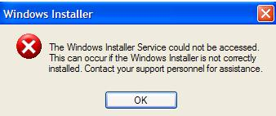

Error dialog result showing Windows Installer is offline

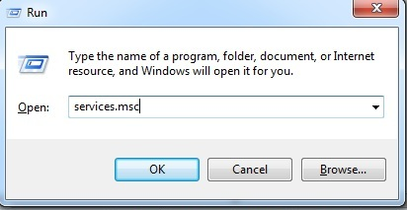

Step 1: press the windows Picture of the Start buttonkey type in the search box “run” and this dialog box will appear.

Step 2: type “services.msc” in the dialog box

* 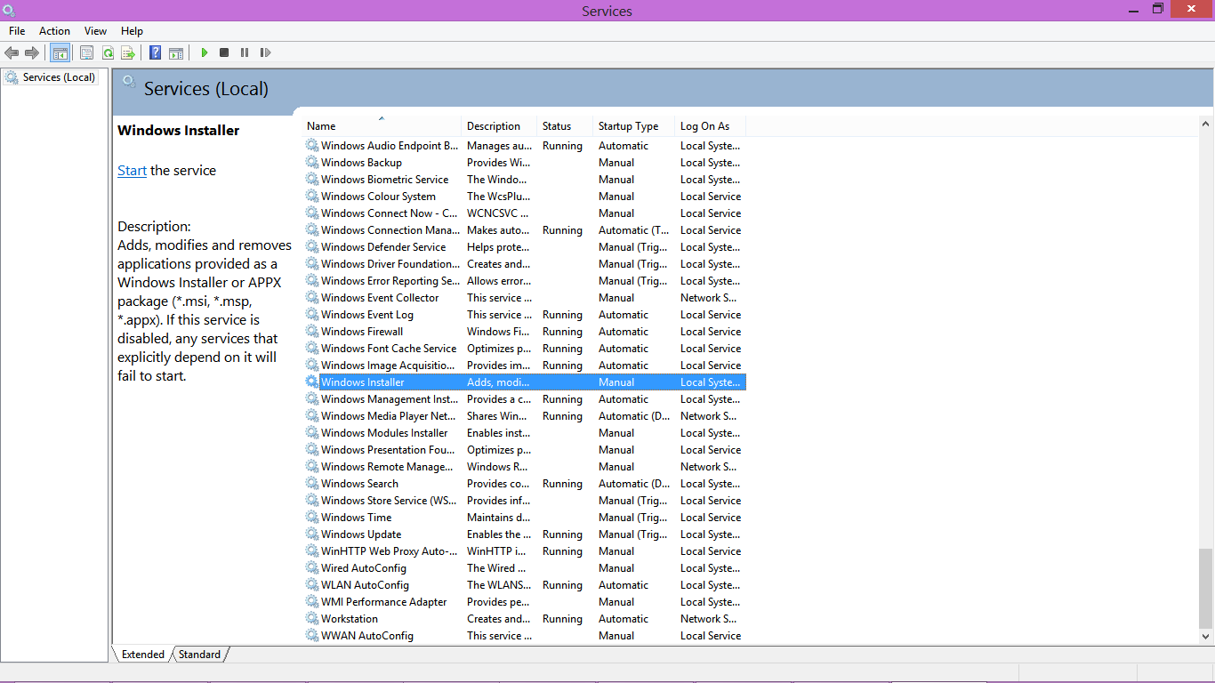Click ok and the window below appears
* Scroll down to WINDOWS INSTALLER service.
* Click Windows installer service, and in the left panel a link label to “start” the service will appear.
* Click start and the service’s status should change to running.
* Now if you try to install any application it should install with no error message.

### Problem: Computer is Slow Booting up

Sometimes after installing a lot of plugins and a lot of software the computer may become a little slower to boot up and less responsive than before this is because there are a lot of background services running on the machine and using up the CPU.

**Solution**: disable unnecessary start up applications to speed up boot time.

**Procedure:**

* Press ctrl-alt-delete buttons simultaneously to bring up these dialog options

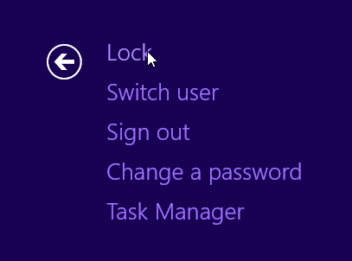

**Showing Windows Task Options**

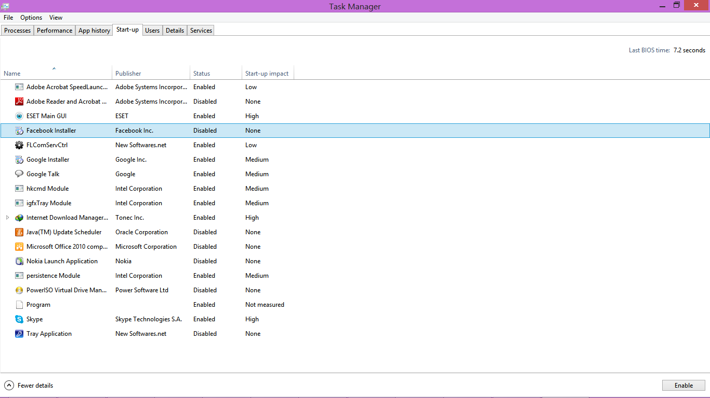

* Select Task Manager Option
* Select Start up Tab.

You then need to disable some of the non-essential processes that will be running on start-up e.g. AcroTray, Facebook Installer, Download Accelerator Plus, Hotspot shield. After this the computer’s boot time will reduce greatly.

### Problem: Computer Unable to download updates.

Sometimes the windows operating system won’t download updates.

**Solution**: Manually downloading and installing windows updates

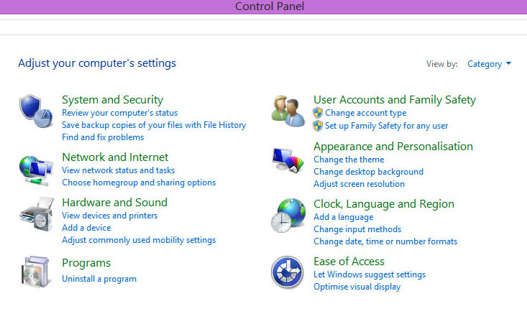Procedure:

Step 1: Go to the control panel and click programs.

Showing Control Panel

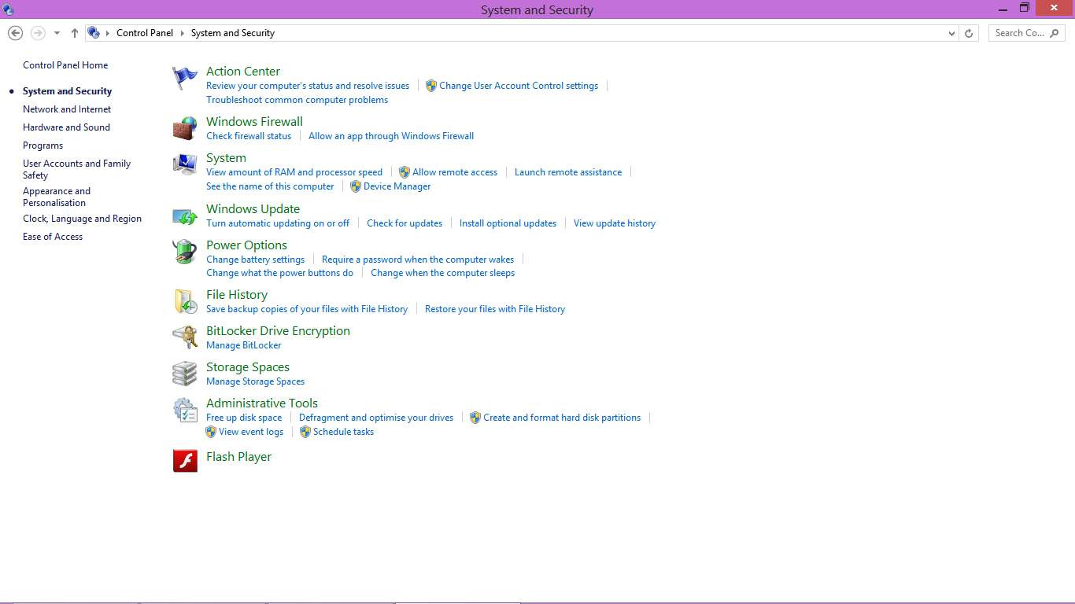

Step 2: Click “system and security” link label

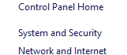

**Control Panel: System and Security Settings**

Step 3: Select Windows Update

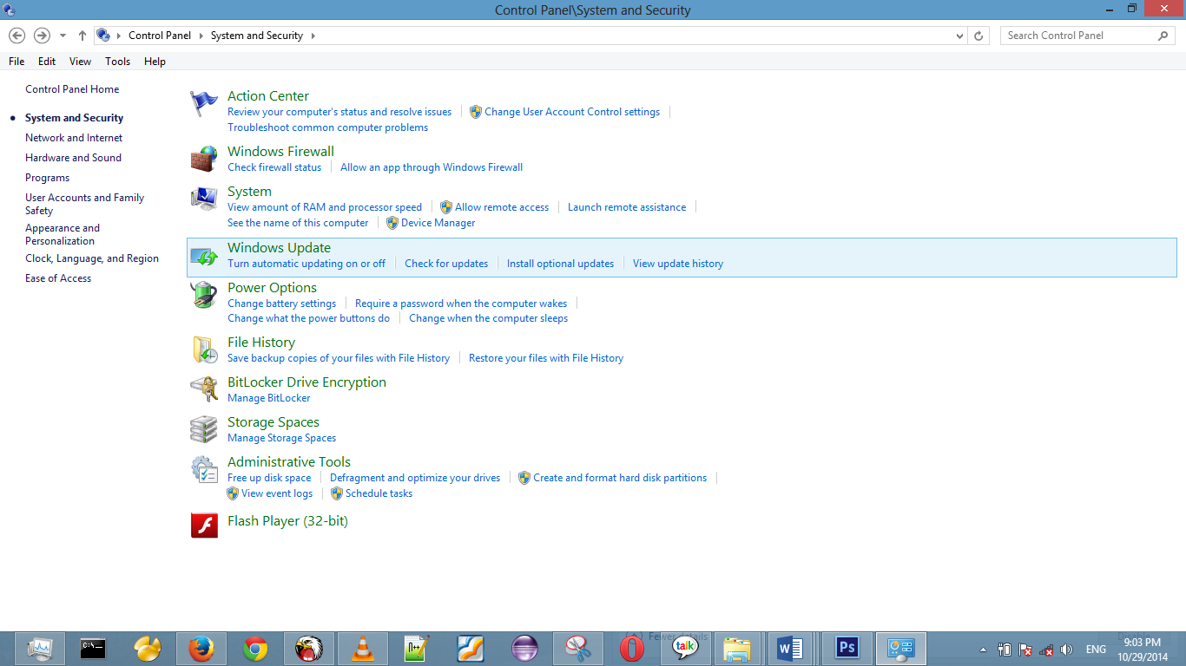

* Check for updates, if there is no internet connection connect to internet and click Try again and then Install update
* Then Click install Updates the updates will install.

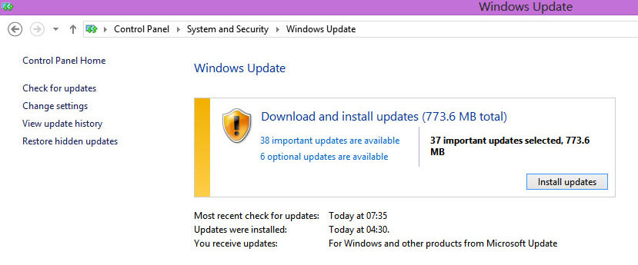

**Control Panel: Windows Update**

### Problem: Computer laptop unable to obtain IP Address from the router

This is a common problem that can occur when IP Address conflicts between two devices persists preventing internet access to one of the devices.

**Solution:** Release the current IP address and renew the IP Address

Procedure:

To release the IP Address of a computer

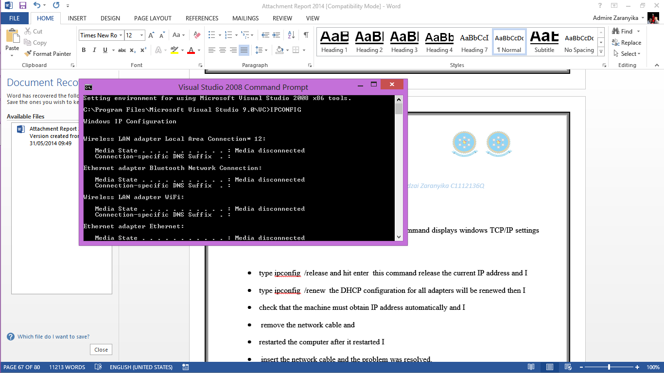**Step 1:** Click the Windows Start Picture of the Start button Button, then Type CMD into the search box.

The command prompt application will appear

Step 2:

* CMD type ipconfig -all and hit enter this command displays windows TCP/IP settings for all your networks.
* Type ipconfig -release and press enter this command will release the current IP address of this computer.
* Type ipconfig -renew the DHCP configuration for all adapters will be renewed
* Ensure that the machine is obtaining IP address automatically and then Restart the Computer
* Insert the network cable and the problem is resolved the computer will now be able to obtain a new IP address.

### Problem: unable to communicate with serial port

**Solution: Updating USB to Serial drivers on the internet**

Procedure:

* Connect the Ethernet cable on the Computer or use a Wi-Fi hotspot
* Right Click on my computer
* Click device manager
* Double click the ports COMM driver.
* Select driver tab
* Click update driver.
* Click update drivers then you will be prompted to choose if you want to update by connecting to the internet and find the drivers online or to search for a program in your computer that will update the drivers in this case I choose to update the drivers on the internet, then the computer searched the proper drivers and I installed them and the computer was now able to connect to the communicate with the serial ports.

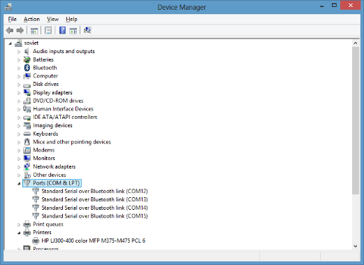

**Step one:** select the COMM & LPT driver icon by double clicking on the driver.

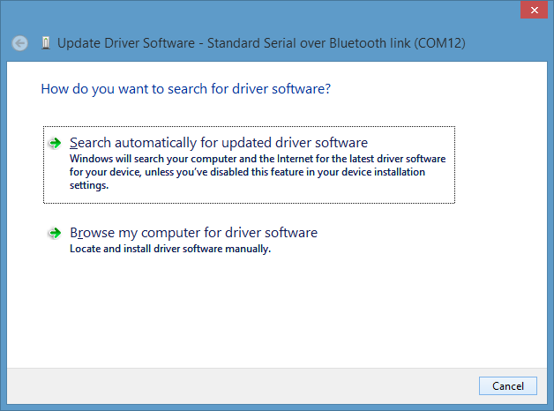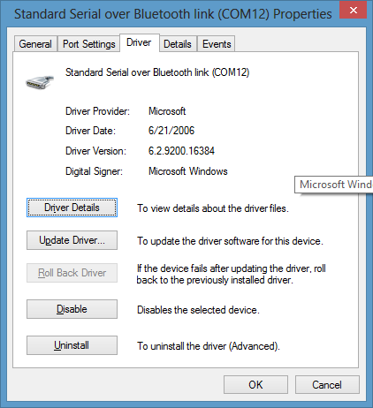**Step two:** select the driver tab: and click update driver

**Step three:** choose the option to search automatically and install drivers

When the computer finishes installing the driver you will be notified and you may now use the serial device to communicate with the computer via the USB port.

### Problem: Disabled wireless network adapter

If the wireless network driver is disabled, you will need to manually enable it.

**Solution**: Enabling the Adapter

Procedure:

* Right Click the network  icon on the task bar.
* 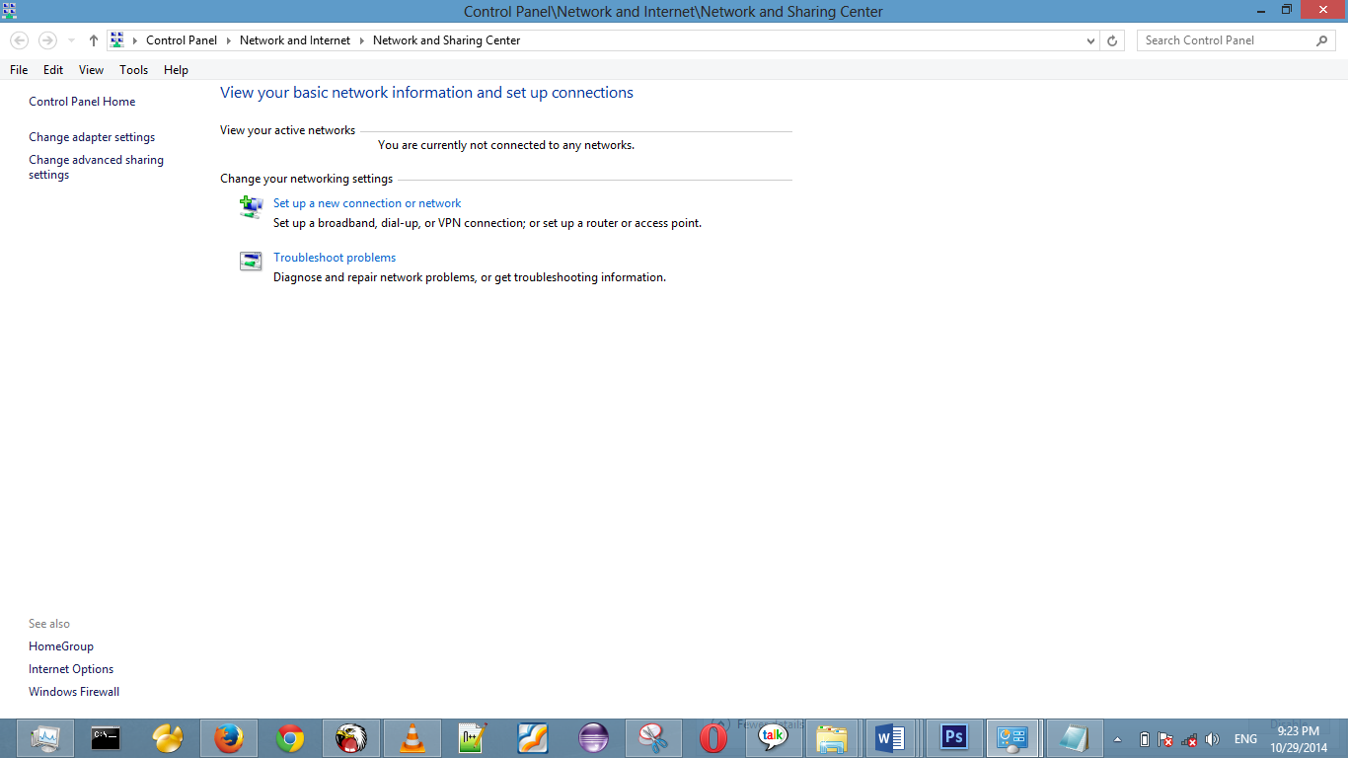Click open network and sharing settings

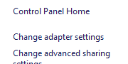

Click Change Adapter Settings

Network and sharing settings

* On the Wireless Adapter Right Click
* Click Enable

The wireless adapter will now be active and wireless networks will be visible now

### Problem: unable to access Webservices on the server.

We use Webservices in parts of our integration in our software solutions. But sometimes if not correctly configured a developer cannot access those web services from a remote computer. This is mainly due to the firewall blocking that the web service can’t get through.

**Solution**: Allow the Webservice through the firewall

Procedure:

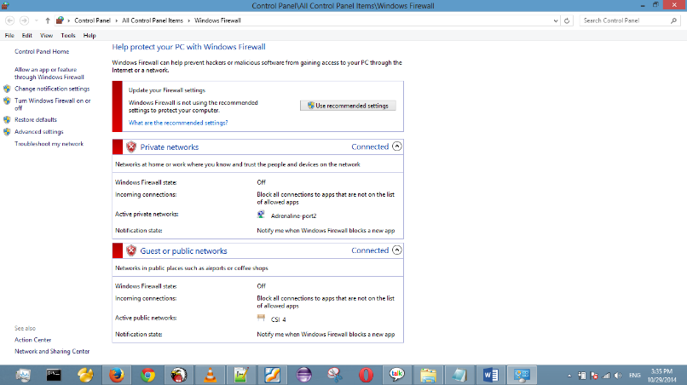To allow the Webservice though the firewall press the Picture of the Start button windows key and type in the search bar “firewall”, this screen will appear

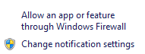

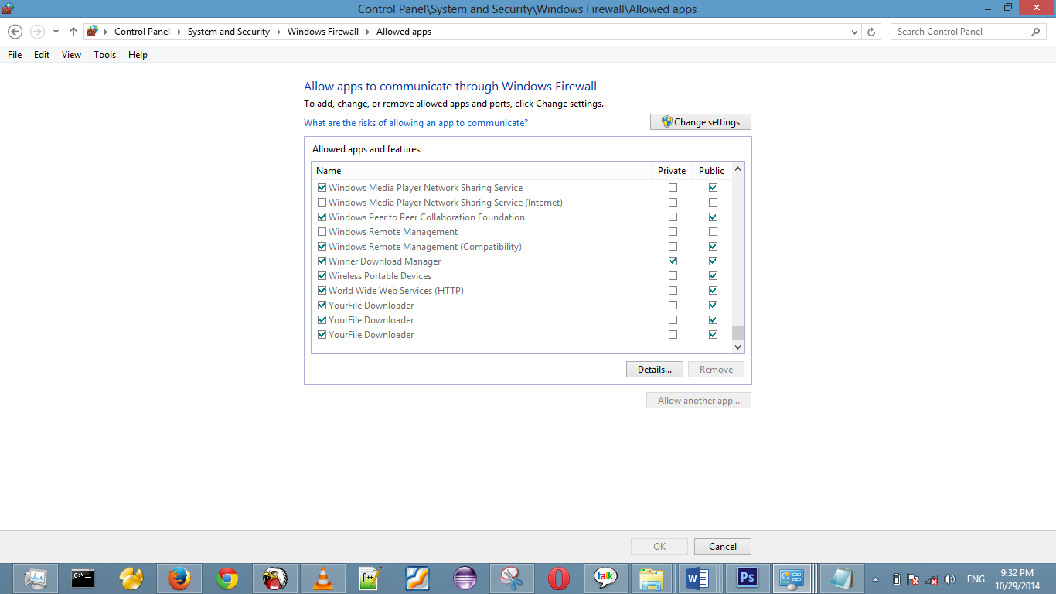Next click the link “allow an app or feature through the windows firewall”

Scroll down until you get to “World Wide Web Services (HTTP)” option and check off public

Then click ok at the bottom of the screen and you can now access the webservices on the server from a remote computer.

### 

### Problem: Operating System Misbehaving/corrupted

An operating system can be corrupted and stop working properly if a user tampers with some settings or if a virus infiltrates the OS and disrupts it.

The specific steps involved in performing a Startup Repair or Repair Install of Windows can differ considerably depending on the operating system used:

**Solution**: Repair Operating system

**Step 1:** insert a bootable disk with the operating system into the computer.

On startup of the computer press “f9” key repeatedly until boot menu options appear

Select boot from flash drive then select boot from drive

**Step 2:** the computer will begin to load the setup files before it asks you if you want to repair the operating system or if you want to install an operating system. If you choose to repair the operating system the operation will start immediately. If you choose to install an operating system the computer will ask you to specify which partition to install the operating system.

**Step 3:** select the partition that you wish to place the operating system.

**Step 4:** wait for the installation to complete then you may proceed to use your computer.

Follow the on-screen instructions to install your operating system to your computer. Allow this process to complete, making sure to type in any requested information including your name and the product CD key number. Reinstall your drivers after the Operating System is fully installed.You will need to reinstall all your utility applications

### Why the option of repairing **corrupted** Operating System?

Often a user may tamper with the operating system’s setting either knowingly or unaware this can cause the OS to misbehave, also sometimes a virus may infiltrate the computer system and disrupt system files this disruption can be so severe that you may have to do a system repair installation. A Repair Installation or Startup Repair of Windows is valuable when you need to reinstall important Windows files but keep all of your personal files and programs intact. A Startup Repair or Repair Install is very often a relatively easy fix for many serious Windows operating system problems. Since these Windows repair options don't erase anything from your computer, you are able to restore important Windows files from your previous installation.

Problems that I encountered that lead me to do a repair installation of my computer were:-

* Computer unable to boot up
* Viral infiltration
* OS misbehaving whilst using my computer

# CHAPTER 5

## Skills gained

### Value of work experience

I learnt new things which groomed me to be a professional IT person when I am given a problem. The attachment has given me a new and positive perspective of work and the workplace. I put a lot of value on work experience since I realized the benefits which come with work experience as compared to raw college studying.

#### Huge workloads management

When I was still new to the company, I had little knowledge of the hardware side of the computer. My supervisor taught me by giving me problems to solve. At first, this was stressful for me as I had to leave some work undone and the unfinished work would keep on piling. This resulted in huge workloads which was a problem for me Because some of the work had stipulated deadlines. However, this Benefited my time management skills and sharpened my hardware knowledge.

#### Only I.S Intern

The whole organization in Zimbabwe division had me as their only Information Systems intern. At times many employees in the organization would need help at the same time. This resulted in employees complaining as they felt they were not Being attended to. This improved my sense of responsibility and enhanced how I arrange my tasks.

#### Linux Operating System

I gained a much more detailed view on the efficiency of this O/S. Many of my tasks under MMT support were done using Linux OS and different distributaries.

#### Office Management

Being in an office setup, office etiquette and management and administration was inevitable. I did not only learn ICT related issues but l also learnt management and administration issues. These includes handling secretarial duties for the superiors and taking minutes in a requirements meeting.

#### Good communication and interpersonal skills

Inevitably information, ideas, feelings and facts are exchanged daily during the course of executing duties, hence communication takes place. Exposure to the use and business etiquette of modern communication such as email and the internet was gained. This enabled sharing of information, and fully utilizing the advantages of Information technology.

#### Work Ethics

Cassava Smartech (Pvt) LTD is a very ethical organization and with the guidance of a very ethical industrial attachment supervisor, I managed to develop good work ethics.

#### Managerial, analytical and diagnostic skills

I managed to emulate good managerial, analytical and diagnostic skills from experienced personnel as a result of team work engaged. I was quick to observe and learn the way my seniors handled and analyzed tasks during crisis. I also learnt how to be responsible and be accountable by being left alone in office. Analytical skills where achieved through handling clients’ problems since the I was supposed to first of all have a look at the problem and then analyze it before coming up with a solution.

#### Prioritization of tasks

During attachment period at Cassava Smartech, I prioritized tasks due to pressure from a lot of ongoing projects that I was assigned. Task scheduling was put up giving the first priority to the most important task in that project. All my given projects were completed in time meaning targets were met. This implies that my time management was good since all my projects were completed on time.

#### Changes in my level of confidence

The issue of dealing with clients in the technical support department on a day to day basis enhanced my communication skills. Some users did not appreciate the efforts of an attaché they have a mentality that attachés do not know, they can even say some harsh words even when their fault is being attended to. I gained a lot of confidence by doing my bid in solving their problems correctly which enabled me to keep working even when such words were being said. The same kind of confidence enabled me to think quickly and respond to the verbal attacks without offending the clients.

Dealing with the executives is one of the challenges I faced considering that most executives need their faults to be attended to and solved up to their expectations mainly because they are time conscious. At one point in time I had to fix a faulty projector and laptop in a top level executive meeting in the board room while everyone was waiting on me to solve the problem and then continue with meeting. Occasions like these really helped me to raise my level of confidence and improve on my level of professional contact.

# 

# CHAPTER 6

## ATTACHMENT OBJECTIVES

### The main objectives of the industrial attachment period are:

#### TO THE ORGANISATION

* The company views the student industrial training process as a training tool for future recruitment purposes. I noticed that more than 50% of the permanent employees at Cassava Smartech were interns of the company at some point. For the company executives, this gives them a chance to know future employees’ performance and character Before they take them in on a permanent Basis.
* The company aims to grasp fresh ideas from students. Some fields like the technology field are always evolving hence course outlines in tertiary institutions evolve too. As such, current students might have some knowledge that might Be valuable for the company.
* In my own opinion, the organization views industrial training as an opportunity to capitalize on cheap labor as interns do not get paid as much as permanent employees and do not have demanding needs.
* To offer students an opportunity to develop hands on experience in the world of business and its intricacies.
* To expose students to behaviors of organizations i.e. both internal and external environments.
* To offer students an opportunity to test their theoretical tools and constructs learnt during their first two years of the degree program with the realities of running business organizations in Zimbabwe and worldwide.
* To solicit the help and experience of business managers, especially supervisors and training officers, in training and developing future managers.
* To offer students an opportunity to develop entrepreneurial skills and knowledge.
* To seek industry’s evaluation of our degree programs in terms of relevance to industry and commerce.

#### OBJECTIVES TO THE STUDENT

* Industrial attachment gives a student an opportunity to put theoretical knowledge into practice. In school students are given the knowledge and most of the material they learn was simulated for learning purposes.
* Give the student an opportunity to gain more practical skills.
* Give the student an opportunity to learn how to work with other people in a professional environment. Gives an opportunity to Be able to understand how a team works and to Be a good member in one.
* The student aims to gain an exposure in pressure situations. They get the ability to work under pressure.
* To Be able to adapt to new working environments and have an ability to get along with new people.

#### OBJECTIVES FOR THE TERTIARY INSTITUTION

* The university aims to equip its students with practical skills to complement the theoretical knowledge they provide.
* The university aims to maintain a consistent exposure of current market trends and employer demands. This helps them to plan their course outlines and to even know which courses to offer.
* The University aims to have its image represented as the students act as ambassadors of their respective universities when they go on attachment. Therefore, if the student displays credible knowledge, the university will get a good recommendation, otherwise, it won’t. This also helps the university to attract top goombay minded students.
* The university aims to complement its relationship with companies nationwide. This might help in collaborating with industry on dynamic programs to work together to prepare tomorrow’s global workforce.
* The University aims to enhance its career services when a student directly recommends an internship to another student.

## Expectations & Industrial Attachment Reality:

#### Introduction

Before attachment at Cassava Smartech, I had various mental perceptions about the IT industry. I also had perceptions about the organization that I got attached to. I was all along wondering how the Academic Courses that I had done at university in Part 1 and 2 would fit in with the operations at Cassava Smartech. After being part of the IS team at Cassava Smartech I noted that most of the courses we learned at UZ were very useful both in terms of the theory we learned and the practical’s that we did. Some of these various perceptions and expectations are outlined hereunder.

#### Prior Expectations

On engagement to the organization I had many expectations. I was also excited at being accepted for Work Related Learning (WRL) being attached in the connected lifestyle operations team and IS operations team I expected:

* An IT department with all departments.
* To work in an environment with the latest computers.
* To work in an environment with highly sophisticated systems and highly sophisticated hardware
* To be programming very complex applications and software projects.
* Working in an environment characterized by the smooth flow of activities and members of staff easily mingling with one another.
* To meet IT experts in the industry and work closely with them so as to gain all the relevant knowledge.
* To provide support services in the decision making of the organization.
* To be fully aware of the recent developments in the ICT environment.

#### What I encountered

Some of my expectations did materialize but the rest was not true. I did work in an environment that had a lot of servers and high-speed internet, and was privileged to work with Zimbabwe’s top network, system admins, DB admins, Ops Engineers, Dev Ops Engineers, Software Developers, I managed to get a desk and an office to work in. There were a lot of things I had taken for granted when I reached the organization for example being formal in all respects but that quickly changed. Even though the ICT section had an open door policy where everyone could come in other offices in the organization did not have such and formal procedures were adhered to. Workloads assigned to me were fair enough, according to the skills I possessed but increased as I gained knowledge in different respects. Other members of the department appreciated that I had come for the purpose of increasing in knowledge and aided me in attain this by being open and giving assistance when needed.

# CHAPTER 7

## **Recommendations**

### Recommendations to Cassava Smartech.

* Cassava Smartech should improve on automation of manual processes. This is a great deal to the business because time in a business-like telecommunication is something which you don’t have. The longer sign-offs stay in circulation, the slower the business moves. This might give competitors like Telecel and NetOne the edge if they have automated sign-offs systems.
* I recommend that the business automate base station monitoring process.
* I recommend that training programs should be arranged for students on attachment. This helps the business to improve on efficiency because students are just coming out of school and have the desire to learn and improve the environment. Training such as Oracle DB Administration and Java Programming.
* I recommended installation of live trackers on all company laptops whereby their location can always Be monitored. If the victim manages to report early enough the laptop could Be found in less than an hour or two.
* I recommend automation of Employee overtime check in.

### Recommendations to UZ

* I recommend the University adds more practical lectures to build students with practical computer skills required in industry especially on the hardware side.
* UZ should provide attachment training programs and recommendations to companies so that the companies can assess what they have and what is expected by the university.
* Lecturers at UZ must review their theory lessons to ensure that what we learn in the class room is relevant and still up to date and in line with what is going on in the industry.
* During attachment, the college should make regular checks on students not necessarily formal visits like assessment.
* I strongly recommend the department of Computer Science to put an extra focus in the internet of things and expert systems. He noticed that in modern day industries, artificial intelligence and the internet of things systems can Be developed and used in almost any field.

# Conclusion

Work Related Learning period at Cassava Smartech (Pvt) LTD was a huge success as set and expected goals were achieved and substantial knowledge and insight gained and attained. Now I can proudly say I am ready to be deployed in the industry.

To present day, the attachment period proved to be a wonderful and an immensely successful experience for me. From the beginning of the internship program, I have learnt that there is more to Computer Science than just being theoretically talented. However, I discovered that more work still needs to be done by both the college and the company to make sure those students on attachment get most out of the work related learning program. All the same, much gratitude is extended to the Cassava Information Systems team for giving me the opportunity to apply the theory that I learnt in school. Furthermore, I would like to extend my gratitude to the IS infrastructure team for making the third year a year for industrial attachment a true work-Related Learning experience. It was a great opportunity and I would like to thank the organization as a whole for making me feel comfortable and assisting me in my learning throughout the year. I hope that during my time at the Organization I also contributed growth of the Organization as a whole.

# References

IBM InfoSphere Guardium Data Security (2019) *Documentation* [Online] Available from:

<https://www.ibm.com/products/software> [Accessed 1st November 2019]

Russell, S. J. & P. Norvig (1995) *Artificial Intelligence: A modern approach*. New Jersey: Alan Apt.

Sommerville, I. (2007), *Software Engineering, Eighth Edition*, China Machine Press, Communications

Pettichord, B. (2002), *Lessons Learned in Software Testing*, John Wiley & Sons

Econet Wireless Zimbabwe Cooperate Profile (2019) *company background* [Online] Available from:

<https://www.econet.co.zw> [Accessed 12th November 2019]

Cassava Smartech (Pvt) LTD Cooperate Profile (2019) *company background* [Online] Available from:

<https://cassavasmartech.com/> [Accessed 13th November 2019]

itwebafrica (2015) *Documentation* [Online] Available from:

<http://www.itwebafrica.com/telecommunications/154-zimbabwe/233234-econet-soars-past-9mn-subscribers-as-telecel-shrinks> [Accessed 13th November 2019]

Droms, R. (1997), *Dynamic Host Configuration Protocol*, Addison-Wesley

Perlman, R. (2000), *Interconnections: Bridges, routers, switches and internetworking protocols, 2nd edition*, Addison Wesley